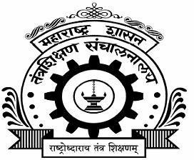















SECOND YEAR DIPLOMA ENGINERING (I-SCHEME).
BRANCH- MECHANICAL ENGINEERING.

SUBJECT : THEORY OF MACHINES









“  ”






2002 | Karne Yashraj Maruti
2004 | Shah Rehan Maksud
2006 | Lohar Sahil Somnath
2007 | Khalate Sanket Krushnat
2009 | Gaikwad Vedant Pravin














Cams are commonly used in engines to control valves ,sewing machines ,childrens toys and many other mechanical applications. The shapes of individuals cams are designed to produce specific types of motion.




- Knowledge of various mechanisms and machines is a prerequisite for enabling a mechanical engineer to work in the industry.
- This course provides the knowledge of kinematics and dynamics of different machine elements and popular mechanisms such as four-link mechanisms, cam-follower, and belt-pulley.
- Chain sprocket, gears, flywheel, brake, and clutch to enable a diploma holder to carry out maintenance of these and it also serves as a prerequisite for the course Elements of Machine Design' to be studied in a later semester.





- Select suitable mechanisms for various applications.
- Interpret the motion of cams and followers.



In this project, we know about the various types of followers and study their applications.



 |  |    |    |     
1. | Selection Of Topic |  |  | All Team Members
2. | Collection Of Information |  |  | All Team  Members
3. | Proposal |  |  | All Team  Members
4. | Report |  |  | All Team  Members




 |  |  |  | 
1. | Computer | Proposal and Report Typing | 1
2. | Internet | Information | 1



 |  |   
2002 | Karne Yashraj Maruti | 2200100476
2004 | Shah Rehan Maksud | 2200100411
2006 | Lohar Sahil Somnath | 2200100413
2007 | Khalate Sanket Krishnat | 2200100414
2009 | Gailwad Vedant Pravin | 2200100416



We take this opportunity to thank all those who have directly and indirectly inspired, directed and assisted us towards successful completion of the project report.
We express our sincere thanks to Principal,  and the Head of department  Sir for having us allowed to submit this report as part of our academics learning.
We express our sincere thanks  lecturer in Theory of machine, Govt. Polytechnic Karad for encouragement throughout the project reports and guideline in designing and working out this project.
We are also grateful to team of this Project they’re highly encouraging and cooperative attitude. We express our sense of gratitude towards our friend and parents for their constant moral support during projects report.




Mr. Karne Yashraj Maruti Mr. Shah Rehan Maksud Mr. Lohar Sahil Somnath Mr. Khalate Sanket Krishnat Mr. Gaikwad Vedant Pravin



This is to certify that, as a part of partial fulfillment of the three years Diploma Course in Mechanical Engineering,Semester IV (I Scheme), the following bonafide students,
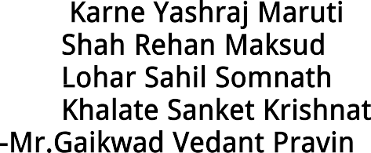


have completed the Micro Project work,titled various types of follower for the subject Theory of machine ,under the guidance of


(Guided By) (Head Of Department)








A follower is a rotating or oscillating element of a machine that follows the movement of the cam with the aid of using direct contact.

A follower is a mechanical element regarding which, the Cam rotates in an oscillatory or round movement. Follower inhibits the push and pulls of the Cam. A follower is used to switch the movement to the desired machine part. The Follower rotates in an oscillating or circular arc.
A follower is a translating or oscillating mechanical member that follows the movement of the cam. It can contact the surface profile of the cam or can be spring-loaded. It will have a uniform speed or can have uniform acceleration movement. Complicated output movement may be done with the help of the follower movement. The mechanism for Cam and the mechanism for Followers rely upon each other so the major mechanism of Cam and Followers. The mechanism is critical in the engineering field and has many different roles for the different machines.

It is a part of the machine, that is principally following a cam that can reciprocate or oscillate in motion. This transforms the rotary movement of the cam into reciprocating or oscillating movement.




.


- 

This type of follower is primarily used in high-speed operation because it has a smooth connection with the surface. This type of follower has less wear and tear as compared to the other followers. In this type of followers sliding motion of knife edged follower is replaced by rolling at low speeds but at high speeds, the sliding motion of the roller can not be completely eliminated.When the contacting end of the follower is a roller, it is called a roller follower,
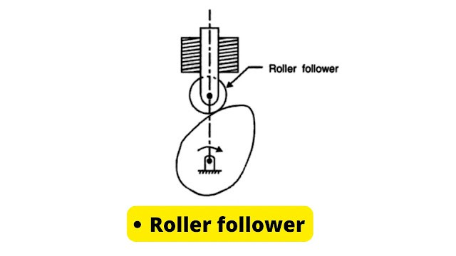


- Cam mechanisms of automatic machines
- Dedicated machines as well as carrier systems
- Conveyors
- Bookbinding machines
- Tool changers of machining centers
- Pallet changers, automatic coating machines and sliding forks of automatic warehouses.



- 

When the contacting end of the follower has a sharp knife-edge, it is called a knife-edge follower, as shown in Fig. This type of follower are simple in construction and the motion between the follower and the cam is of sliding motion. In this sliding motion is occurring.As per its name knife-edge follower has a sharp knife edge which comes into contact with the cam. The motion is take place between the cam and the sharp knife edge. In this follower a considerable side thrust exists between the guide and the followers. It is simple in construction but the use of this follower is very limited because high wear and tear takes place at the point of contact.
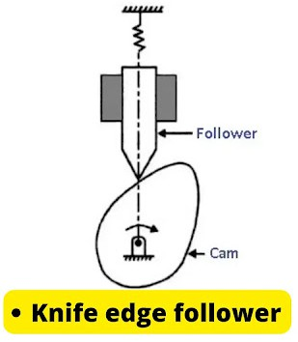



- Applications that work with speed only slow ones, due to its sharp edge.




The flat-faced follower looks as if on a flat surface with an irregular cam. In this, the cam is applied when the area is limited and this follower can keep extra thrust. This follower also can be implemented in a particular application.

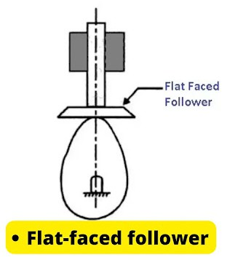



- To operate valves in a car engine. where space available is limited.


As the name suggests the contacting surface is the shape of a Mushroom (circular in shape) or flat. There is very less side thrust seen in this case as compared to the roller and knife-edge follower which make it stable even at high speed and it does not cause any problem of jamming of the cam. In these followers high surface stresses are induced due to the misalignment and deflection, this is the major drawback of this follower.



- This type of follower is mainly used in high-speed operation because it has a smooth contact with the surface.



- 
In this type of follower, as the cam rotates, the follower reciprocates or changes into the guide.In this type the motion of the follower is reciprocating or translating in the guides where as cam rotates uniformly.
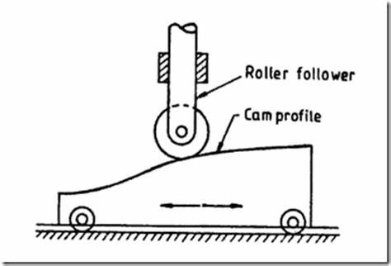



The oscillating follower is placed at a proper point on the frame and oscillates thus the cam causes the rotary motion. In this case the follower oscillates when the cam rotates. The follower is pivoted at a fix position where oscillating or rotating motion in the follower takes place.
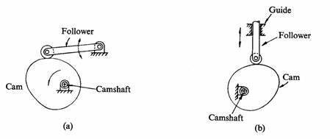





The radial follower is used when the line of movement of the follower passes through the center of rotation of the camshaft. It is in a reciprocating motion. When the line of action of the motion of the follower is passes through the center of rotation of the cam then it is known as the radial follower.

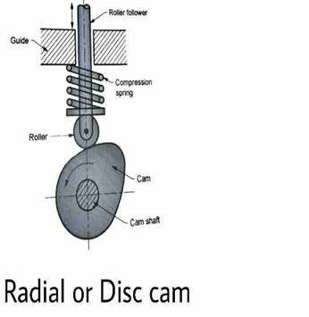



The offset follower is used when the line of motion of the follower is offset from the center of rotation of the camshaft. when the line of action of motion of the follower is offset/ away from the center of rotation of the cam then it is known as off-set followers.
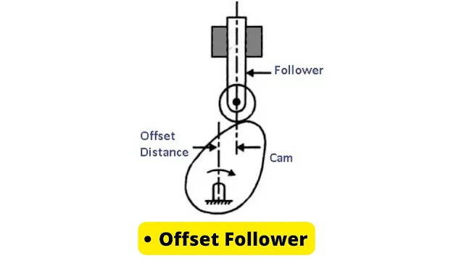




 |    |  | 
1 | computer | windows 7 | 1
2 | internet | youtube
3 | textbook | Theory Of Machine (22438) | 1


In this micro project, we get all information about types of followers and study their applications.








a.Develop group discussion skills. b.Communication skills improved.
c. MS WORD skills developed. d.know about followers.


Follower inhibits the push and pulls of the Cam. A follower is utilized to transfer the motion to the required machine portion. The Follower rotates in an oscillating or circular arc.

